Cause No. 2017-50825

EcoHub, LLC (for itself and as an assignee of EcoHub-Houston, LLC); Dolcefino Communications, LLC d/b/a Dolcefino Consulting; and Wayne Dolcefino, Individually  Petitioners,  v.  City of Houston, Texas,  Respondent. | §  §  §  §  §  §  §  §  § | In the District Court  of Harris County, Texas  11th Judicial District

Petitioners’ Opposed Motion for Issuance of an Order to Show Cause Why the City of Houston Should Not Be Held In Civil Contempt of Court

and

Motion for Sanctions

On March 29, 2018, the Court ordered the City of Houston as follows:
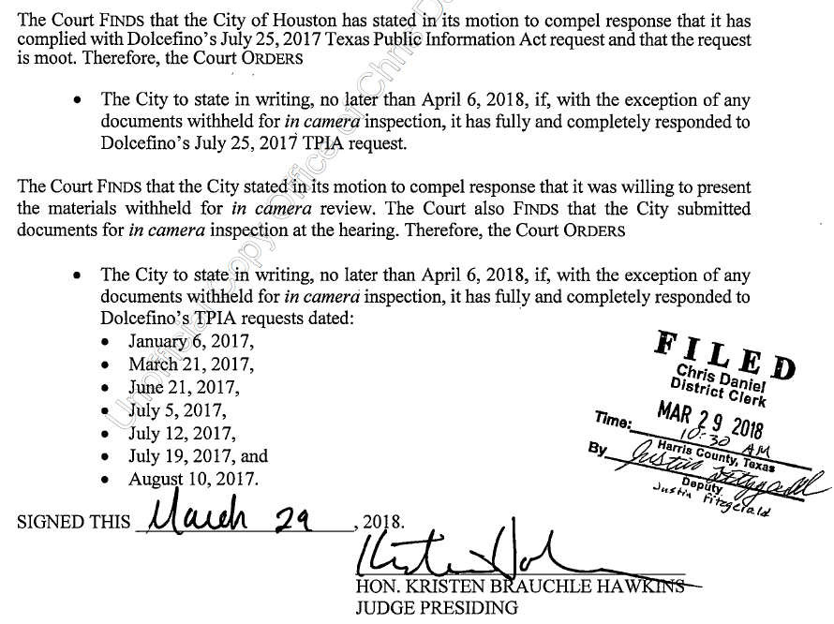
[Exhibit 1, March 29, 2018 Order]. The City never complied with this Order. Instead, the City took a meritless interlocutory appeal to the First Court of Appeals, which the Court of Appeals recently dismissed for want of jurisdiction. [Exhibit 2, Memorandum Opinion, at p. 13]. Notably, the Court of Appeals also rejected the City’s request for a writ of mandamus as to the Court’s March 29, 2018 Order. Moreover, the City forgot to request a stay of this Court’s order – either from this Court, or from the Court of Appeals – which it could have done at any time. As a result, the City has been in civil contempt of the Court’s March 29, 2018 Order since April 6, 2018 – a total of 228 days.

Motion for Issuance of Show Cause Order and Motion for Finding of Contempt.
Given the City’s failure to comply with the Court’s March 29, 2018 Order, Dolcefino Communications, LLC d/b/a Dolcefino Consulting and Wayne Dolcefino (collectively “Dolcefino”) hereby request the Court to issue a show cause order and hold an evidentiary hearing for the City of Houston to show cause why it should not be held in contempt of court for its failure to comply with the Court’s March 29, 2018 Order.
A court can exert its contempt power through two types of contempt orders—civil and criminal. Galtex Prop. Investors, Inc. v. City of Galveston, 113 S.W.3d 922, 927 (Tex. App. – Houston [14th Dist.] 2003, no pet.). A criminal contempt order punishes a party for disobedience of a court order. Id. The maximum punishment that a district court can assess under its criminal contempt power is a fine of not more than $500, or confinement in the county jail for not more than six months, or both. Tex. Civ. Prac. & Rem. Code § 21.002(b). Alternatively, a civil contempt order is used to coerce a party to comply with an order of the court. Galtex. Prop., 113 S.W.3d at 927. For civil contempt, the statute does not limit the maximum fine that a court can impose for civil contempt order. Id.
Should the Court determine, after notice and an evidentiary hearing, that the City is guilty of criminal contempt of Court, Dolcefino requests the Court to issue written findings memorializing that fact, and punish the City for criminal contempt by imposing the maximum fine permitted by law (which is $500.00), and consider whether the evidence warrants some material period of jail time for the relevant decision-maker. Tex. Gov’t Code § 21.002(b). If the Court finds that the City is guilty of civil contempt of court, Dolcefino requests the Court to issue written findings memorializing that fact, and punish the City for civil contempt by imposing a fine within the Court’s discretion, but in an amount not less than $50 per day for each day the City has been, or continues to be, in contempt – importantly, Texas Government Code Section 21.002(b) does not limit the maximum fine the Court can impose for civil contempt. See In re Reece, 341 S.W.3d 360, 366 n.9 (Tex. 2011); Galtex Prop., 113 S.W.3d at 927 (Tex. App. – Houston [14th Dist.] 2003, no pet.). If the Court decides to impose a fine, it should be made payable to the Harris County District Clerk, since the Court may not use its contempt power to provide a damages recovery to a private litigant. Galtex Prop., 113 S.W.3d at 928.

Motion for Sanctions
In addition, or alternatively, Dolcefino requests the Court to consider awarding sanctions against the City for its failure to comply with the Court’s Order and/or the City’s efforts to delay these proceedings with its frivolous appeal. To that end, a trial court has the inherent authority to impose sanctions on its own motion, and the Court has “wide discretion” in that regard. See In re Bennett, 960 S.W.2d 35, 40 (Tex. 1997) (orig. proceeding); Daniel v. Kelley Oil Corp., 981 S.W.2d 230, 234 (Tex. App. – Houston [1st Dist.] 1998, pet. denied); Khan v. Valliani, 439 S.W.3d 528, 537 (Tex. App.—Houston [14th Dist.] 2014, no pet.).

As a sanction, Dolcefino requests the Court to:

overrule the City’s claimed statutory exemptions from disclosure as to the TPIA requests set forth in the Court’s March 29, 2018 order; and

award an amount representing a reasonable attorney’s fee and any costs in an amount not less than $12,500 for the work Dolcefino’s attorneys had to perform to:

draft and attend the hearing on Dolcefino’s Motion to Compel filed 11/20/17 and First Amended Motion to Compel filed 12/1/17, which led the Court’s March 29, 2018 order that the City has contemptuously failed to follow;

defend against, and attend the hearing on, the City’s Motion to Reconsider (filed 12/21/17); and

draft and attend the hearing on the instant Motion.
DATE: November 20, 2018 Respectfully submitted,

Hicks Thomas llp

a registered limited liability partnership

By: ________________________________
Stewart Hoffer
Texas Bar No. 00790891
shoffer@hicks-thomas.com
700 Louisiana, Suite 2000
Houston, Texas 77002
713.547.9100 (Telephone)
713.547.9150 (Facsimile)

Attorneys for Petitioners

Certificate of Conference

I hereby certify that, via email on November 6, 2018, I attempted to avoid the need for court intervention and conferred with opposing counsel as to the relief sought herein; counsel has indicated they are opposed to such relief.

_____________________________
Stewart Hoffer

Certificate of Service

I hereby certify that, on November 20, 2018, a true and correct copy of this Motion has been served to all counsel of record, at the address listed below using the method(s) listed below, as follows:

Ronald C. Lewis, City Attorney Via E-Service and/or Email
Judith Ramsey, Chief, General Litigation Section
c/o Patricia L. Casey
Sr. Assistant City Attorney
pat.casey@houstontx.gov
Suzanne R. Chauvin
suzanne.chauvin@houstontx.gov
Sr. Assistant City Attorney
City of Houston Legal Department
900 Bagby, 4th Floor
Houston, Texas 77002

_____________________________
Stewart Hoffer

Cause No. 2017-50825

EcoHub, LLC (for itself and as an assignee of EcoHub-Houston, LLC); Dolcefino Communications, LLC d/b/a Dolcefino Consulting; and Wayne Dolcefino, in his individual capacity,  Petitioners,  v.  City of Houston, Texas,  Respondent. | §  §  §  §  §  §  §  §  §  §  §  §  § | In the District Court  of Harris County, Texas  11th Judicial District

Order Setting Show Cause Hearing

Petitioners’ Opposed Motion for Issuance of an Order to Show Cause Why the City of Houston Should Not Be Held In Contempt of Court and Motion for Sanctions filed by Petitioner Wayne Dolcefino is granted as set forth herein. It is accordingly,
ORDERED that the City of Houston, Texas shall appear before this Court on __________________, 20___ at _________ ___.m. The purpose of the hearing is to determine whether the City of Houston shall be held in criminal and/or civil contempt for disobedience of this Court’s Order, dated March 29, 2018, by failing to (1) state in writing that it has fully and completely responded to Dolcefino’s July 25, 2017 TPIA request (save the documents submitted in camera); and (2) state in writing that it has fully and completely responded to Dolcefino’s TPIA requests dated January 1, 2017, March 21, 2017, June 21, 2017, July 5, 2017, July 12, 2017, July 19, 2017, and August 10, 2017.
Because the City of Houston has demonstrated an unwillingness to adhere to its obligations under the TPIA, and because the City of Houston had the opportunity to avoid having the Court involved in the instant dispute by simply agreeing to a date certain by which it would respond to the July 25, 2017 request, and because the City of Houston improperly withheld responsive documents and needlessly demanded in camera inspection of the same, the Court hereby awards to Petitioner Wayne Dolcefino an award of reasonable attorney’s fees and costs in the amount of $_____________ as permitted by Tex. Gov’t Code § 552.323 and the Court’s inherent authority. See In re Bennett, 960 S.W.2d 35, 40 (Tex. 1997) (orig. proceeding); Daniel v. Kelley Oil Corp., 981 S.W.2d 230, 234 (Tex. App. – Houston [1st Dist.] 1998, pet. denied); Khan v. Valliani, 439 S.W.3d 528, 537 (Tex. App.—Houston [14th Dist.] 2014, no pet.).
A copy of this order shall be served upon the City of Houston’s attorney of record, Patricia L. Casey, Sr. Assistant City Attorney, 900 Bagby, 4th Floor, Houston, Texas 77002.

SIGNED THIS _______________________, 20____.

___________________________________
HON. KRISTEN BRAUCHLE HAWKINS
JUDGE PRESIDING

